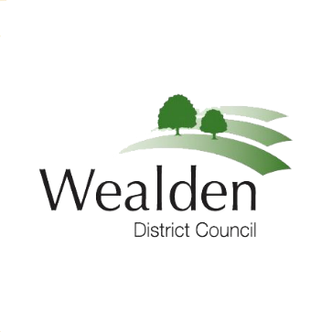

MEDIA RELEASE

073/20 9 December 2020

Wealden proposes a zero council tax rise
Wealden District Council is not proposing any increase in its part of the council tax for the coming year, 2021/22.
“It has been a difficult year for everyone,” said Cllr Bob Standley, Leader of Wealden District Council. “Thanks to many years of careful financial management, we are able to meet next year’s extra costs from our reserves. This is the rainy day we have prepared for.
“I am pleased to propose that there will no increase in Wealden District Council’s part of Council Tax in 2021/22 which makes up approximately 10% of the total. As well as using our reserves, we will be following the Government’s recommendations on public sector pay. Naturally, councillors’ allowances will also be kept at current levels for 2021/22.
“I know that many households across the District have seen their incomes affected by the Covid pandemic. I hope this is one of a number of pieces of good news we can look forward to in 2021.”
“The Covid pandemic has increased the responsibilities for the Council while at the same time reducing the amount of money we are able to earn from our many services. We have responded well. We have taken on new roles delivering financial support across the local economy and looking after those in our community in need of assistance.
“The additional costs of extra services, coupled with the loss of income from our own services, means we are some £500,000 out of pocket. We are hoping this gap will narrow further as further help from the Government becomes available.”
The Cabinet proposal will now go out to consultation with the public, local business groups, parish and town councils and the Wealden Local Strategic Partnership. You can find out more information on the Consultation pages of the Wealden website. The final decision on Wealden’s Council tax will be taken by Full Council on 24 February, 2021.
Wealden’s part of the District’s overall council tax helps pay for refuse and recycling collections, planning, street cleaning, environmental protection and free car parking. The rest of your council tax helps pay for public services provided by East Sussex County Council, Sussex Police, East Sussex Fire and Rescue and local town and parish councils.

For further information:
Bob Standley,  Leader,  Wealden District Council.  Tel: 01892 783579  Email: cllr.bob.standley@wealden.gov.uk  Trevor Scott,  Chief Executive,  Wealden District Council.  Tel: 01892 602524  Email: trevor.scott@wealden.gov.uk | Or | Jim van den Bos  Communications Officer,  Wealden District Council.  Tel: 01892 602745  Email: jim.vandenbos@wealden.gov.uk

